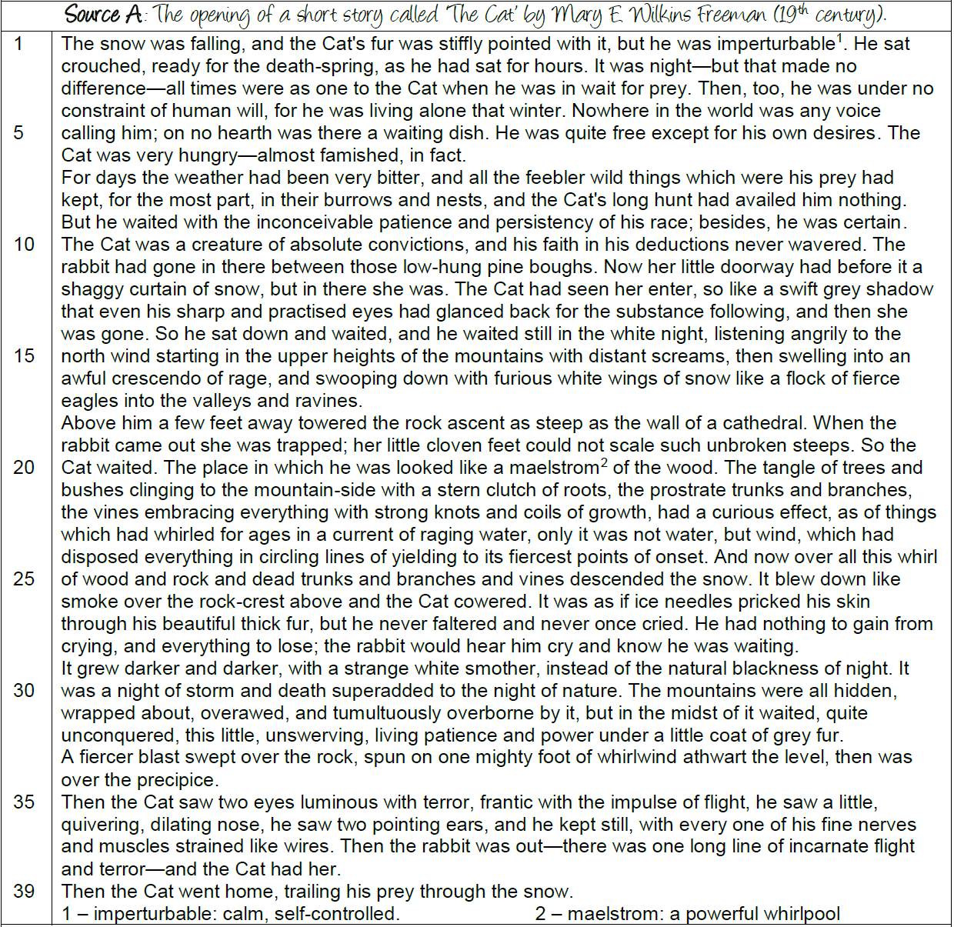

- Read Source A, the opening of a short story called ‘The Cat’ by Mary E Wilkins Freeman.
- WHAT: Plot out the structure of the story on the narrative triangle. Include:
- At least one example of exposition
- Two examples of rising action, including any shifts in focus (e.g. from the cat to the weather)
- Where the writer zooms in on a small detail
- A climactic moment
Hint: the structure strip might have some ideas to help you!
- Now add in short quotations that you can use to anchor your observations (i.e. show where they occur in the text)
- WHY: For each observation, write down why this interests the reader (e.g. what is makes them think/feel; what it suggests; what atmosphere it creates etc.)
- Write up your answer using the structure strip opposite.

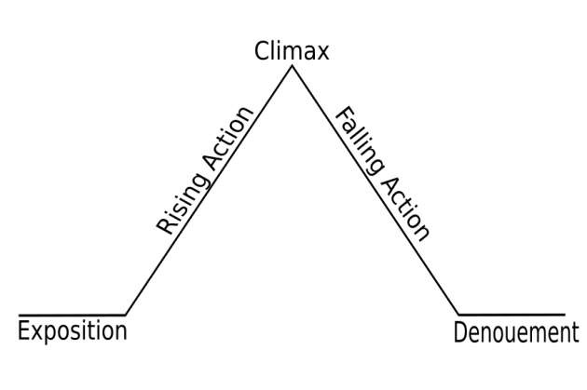

Explain what the author focuses our attention on at the beginning of the extract.

Use these words in your explanation:
- exposition
- analepsis (flashback)

and explain how this opening would arouse the reader’s interest.
Now, explain what the narrative focus shifts to and explain what the purpose of the description is.

Use these words in your explanation:

- narrative focus shifts to …
- rising action

and explain how and why this authorial description adds more interest for readers of this story.
Now explain how the episode ends and why it is interesting to the reader.

Use these words in your explanation:
- climax
- use of dashes
- isolated sentence

