Paper 2A:
Writers’ Viewpoints
and Perspectives

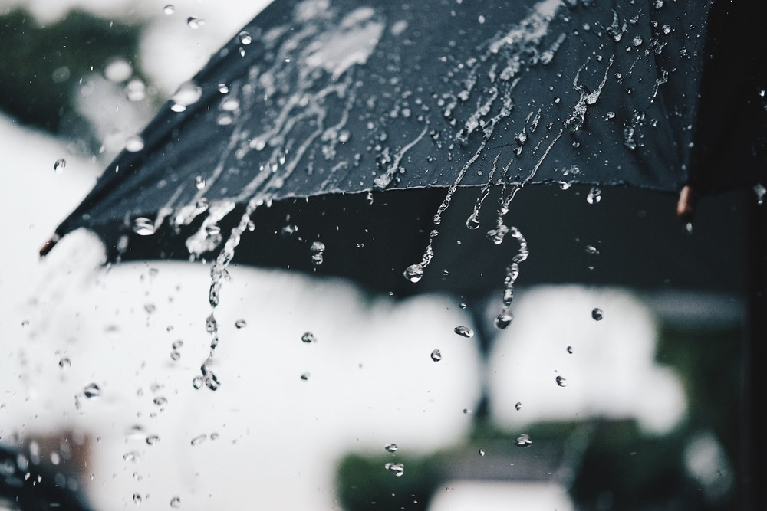

Full Section A: Rain

Name:

SOURCE A: Jottings about London by Edmondo de Amicis (1883)

He who has not seen London in the rain, has not seen the real London; and I had this ‘pleasure’ the morning I went to see the Tunnel under the Thames. Then I understood how, in such weather, one can be seized with the temptation to give one's self a pistol shot. The houses drip as if sweating; the water seems not only to descend from the heavens, but also to ooze from the walls and ground; the sombre colours of the buildings turn yet gloomier and take on an oily look; the beginnings of the streets seem like entrances to grottos; everything seems foul, used up, mouldy, and sinister; the eye knows not where to look without meeting something disagreeable; one feels shudderings, which have the effect of a sudden attack of misfortune; one feels an irksome sense of weariness, a disgust with everything: an inexpressible wish to go out like a lamp from this weary world.

SOURCE B: Rain by Melissa Harrison (2016)

What does rain mean to you? We love to grumble about it, yet we invent dozens of terms to describe it and swap them gleefully; it trickles through our literature from Geoffrey Chaucer to Alice Oswald, and there are websites and apps that mimic its sound, soothing us while we work or sleep Rain is what makes the English countryside so green and pleasant; it’s also what swells rivers, ﬂoods farms and villages and drives people out of their homes.
Because it's something that sends most of us scurrying indoors, few people witness what actually happens out in the landscape on a wet afternoon. Clouds gather and rain falls, changing how the English countryside looks, smells and sounds, and the way the living things in it behave. And the falling rain alters the landscape itself, dissolving ancient rocks, deepening river channels and moving soil from place to place. Rain is co-author of our living countryside; it is also a part of our deep internal landscape. which is why we become fretful and uneasy when it‘s too long withheld. Fear it as we might, complain about it as we may, rain is as essential to our sense of identity as it is to our soil.
And there’s something else that rain gives us; something deeper and more mysterious, to do with memory, and nostalgia, and a pleasurable kind of melancholy. Perhaps there have simply been too many novels with storm-drenched emotional climaxes and too many ﬁlms in which sad protagonists look out through rain- streaked windows, but it seems to me that rain is a mirror of one of our key emotional states: not a negative one at all, but deeply necessary — just as necessary as joy.

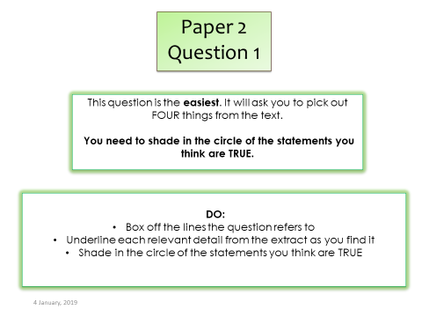

Q1: Read Source B.

TICK four statements below which are TRUE.

- The writer says we love to grumble about rain.

- The writer says people enjoy being outside in the rain.

- The writer mentions the way rain looks, smells and sounds.

- The writer says we’re happy when it doesn’t rain for a long
time.

- The writer says rain is essential to our sense of identity.

- The writer mentions films with rain-streaked windows in
them.

- The writer doesn’t like rain at all.

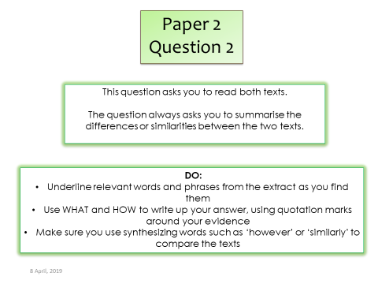

Q2: Refer to source A and Source B.

Write a summary of the differences in the way that the two writers describe rain.

WHAT does the writer in Text A tell us about rain?
_____________________________________________________________________________________________________________________________________________________________________________________________________________________________________________________________________________________________________________________________________________________________________________________________________________________________________________________________________________________________________________________________________________________________________________________________________________________________________________________________________________________________________________________________________________________________________________________________________________________________________________________________________________________________________________________________________________________________________________________________

One thing we learn about rain in Text A is…

HOW does he do this?

Include a quotation from the extract and dig in.

The writer says…
…which suggests…

Now COMPARE this to the description of rain in Text B by using a linking word.

Whereas/unlike/however/ on the other hand…

WHAT does the writer in Text B tell us about rain?

One thing we learn about rain in Text B is…

HOW does he do this?

Include a quotation from the extract and dig in.

The writer says…
…which suggests…

WHAT does the writer in Text A tell us about rain?
_____________________________________________________________________________________________________________________________________________________________________________________________________________________________________________________________________________________________________________________________________________________________________________________________________________________________________________________________________________________________________________________________________________________________________________________________________________________________________________________________________________________________________________________________________________________________________________________________________________________________________________________________________________________________________________________________________________________________________________________________

One thing we learn about rain in Text A is…

HOW does he do this?

Include a quotation from the extract and dig in.

The writer says…
…which suggests…

Now COMPARE this to the description of rain in Text B by using a linking word.

Whereas/unlike/however/ on the other hand…

WHAT does the writer in Text B tell us about rain?

One thing we learn about rain in Text B is…

HOW does he do this?

Include a quotation from the extract and dig in.

The writer says…
…which suggests…

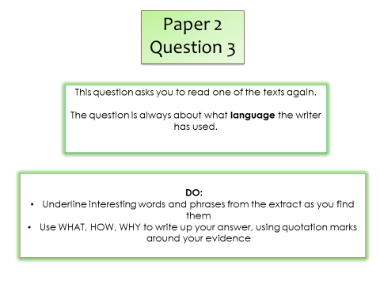

Q3: Re-read the extract below, from Source A.

The houses drip as if sweating; the water seems not only to descend from the heavens, but also to ooze from the walls and ground; the sombre colours of the buildings turn yet gloomier and take on an oily look; the beginnings of the streets seem like entrances to grottos; everything seems foul, used up, mouldy, and sinister; the eye knows not where to look without meeting something disagreeable; one feels shudderings, which have the effect of a sudden attack of misfortune; one feels an irksome sense of weariness, a disgust with everything: an inexpressible wish to go out like a lamp from this weary world.

How does the writer use language to describe rain?

Write your ideas up here:

______________________________________________________________________________________________________________________________________________________________________________________________________________________________________________________________________________________________________________________________________________________________
______________________________________________________________________________________________________________________________________________________________________________________________________________________________________________________________________________________________________________________________________________________________
______________________________________________________________________________________________________________________________________________________________________________________________________________________________________________________________________________________________________________________________________________________________
______________________________________________________________________________________________________________________________________________________________________________________________________________________________________________________________________________________________________________________________________________________________
______________________________________________________________________________________________________________________________________________________________________________________________________________________________________________________________________________________________________________________________________________________________
______________________________________________________________________________________________________________________________________________________________________________________________________________________________________________________________________________________________________________________________________________________________
______________________________________________________________________________________________________________________________________________________________________________________________________________________________________________________________________________________________________________________________________________________________
__________________________________________________________________________________________________________________________________________________________________________________________________________________________________________________________________________________________________________________________________________________________________________________________________________________________________________________________________
Rain is presented as…
The word/phrase/[T] ‘…’ literally means that…
The word/phrase/[T]‘…’ could suggest…
The writer describes rain this way to make us feel…
______________________________________________________________________________________________________________________________________________________________________________________________________________________________________________________________________________________________________________________________________________________________
__________________________________________________

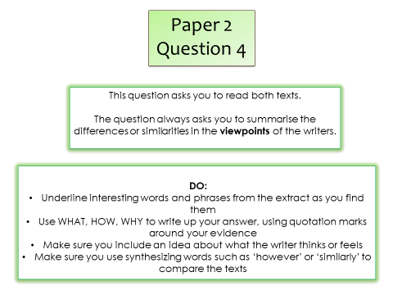

Q4 For this question, you need to refer to the whole of Source A, together with Source B.

Compare how the two writers convey their different views on rain.

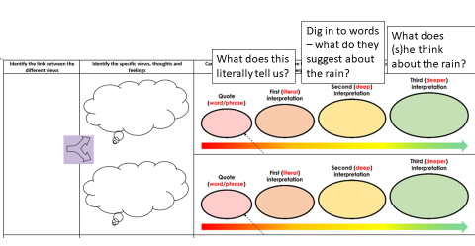

Write your ideas up here:
____________________________________________________________________________________________________________________________________________________________________________________________________________________________________________________________________________________________________________________________________________________________________________________________________________________________________________________________________________________________________________________________________________________________________________________________________________________________________________________________________________________________________________________________________________________________________________________________________________________________________________________________________________________________________________________________
INTRODUCTION: Both writers show their perspective of ...

SOURCE A: WHAT does the writer in Source A think about rain?

The writer in Source A thinks...

HOW does he suggest this?

Include a quotation from the extract and dig in.
He writes ‘…’ This literally means…
The [T] ‘…’ suggests…

WHAT does this tell us he thinks?

This tells us that the writer thinks…

Now COMPARE this to the writer’s thoughts in Text B by using a linking word.

Whereas/unlike/however/ on the other hand…

SOURCE B: WHAT does the writer in Source B think about rain?

The writer in Source B thinks...

HOW does she suggest this?

Include a quotation from the extract and dig in.
She writes ‘…’ This literally means…
The [T] ‘…’ suggests…

WHAT does this tell us she thinks?

This tells us that the writer thinks…

____________________________________________________________________________________________________________________________________________________________________________________________________________________________________________________________________________________________________________________________________________________________________________________________________________________________________________________________________________________________________________________________________________________________________________________________________________________________________________________________________________________________________________________________________________________________________________________________________________________________________________________________________________________________________________________________

